MTSU is now using the “Tutor Me” service to assist students online. This does not replace the Writing Center for writing and reading assistance, but it can be useful for those who need help in the wee hours. All new D2L pages will have the “Tutor Me” link along the Nav[igation]bar (the line that begins with “Course Home” – see photo).

If you have copied an old D2L course shell into a new one, you may not have the “Tutor Me” link on your Navbar.
To add, go to the right end of the Navbar and right click the ellipsis button. This should bring up two options. Right click the top one (“Edit this Navbar”). This opens the “Edit Navbar” page. Scroll down to the gray “Add Links” button (see photo) and right click to open a long list of items you can add to your Navbar. Scroll down to “Tutor Me,” right click the little box beside the item, then right click the blue box at the bottom that says “Add.”
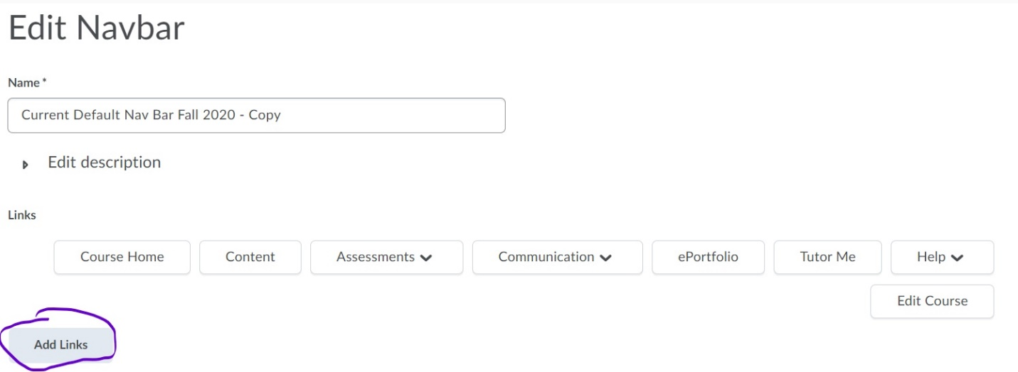

That’s all you need to do – once for each course you are teaching.
Any questions? Email elyce.helford@mtsu.edu or, for complex D2L matters, contact ITD at itdacad@mtsu.edu.

