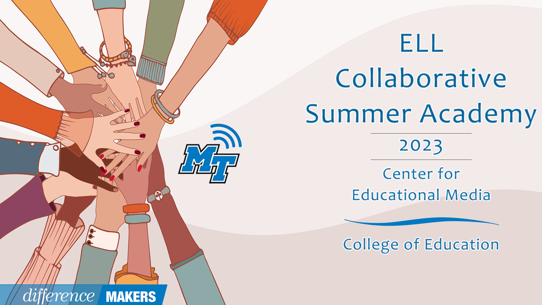
ELL Collaborative Summer Academy
Admin Day
Onsite Conference
July 07, 2023

8:30- 8:45am Welcome/Introductions
- Dr. Laura Clark, Director, Center for Educational Media, MTSU

8:45-10:00 (Session 1) District and School Leaders Supporting the Success of English Learners
- Joann Runion, Senior Director of Unique Learning Needs, TDOE
- Dr. Hannah Gribble, Title III and Migrant Education Program Grant Manager, TDOE
- Q&A Facilitated by Dr. Laura Clark

10:00-10:15 Break

10:15-11:45 (Session 2- P1) The Science of Reading and Multilingualism: Supporting the Literacy and Language Development of English Learners
- Dr. Janna McClain, Elementary & Special Education, MTSU
- Aerial Mosley, Ed.S, Murfreesboro City Schools English Language Development Specialist
- Q&A Facilitated by Dr. Laura Clark

11:45pm-1:10 Lunch

ELL Collaborative Summer Academy
Admin Day
Onsite Conference
July 07, 2023

1:10-1:15 Welcome back/ Return to your seats

1:15pm –2:45pm (Session 2- P2) The Science of Reading and Multilingualism: Supporting the Literacy and Language Development of English Learners
- Dr. Janna McClain, Elementary & Special Education, MTSU
- Aerial Mosley, Ed.S, Murfreesboro City Schools English Language Development Specialist
- Q&A Facilitated by Dr. Laura Clark

2:45pm-3:00pm Break

3:00pm-4:15pm (Session 4) Connecting the Dots: Creating an Authentic Data Platform for Systematic ELP Growth
- Emily Bruner, ELL Program Coordinator, Anderson County Schools
- Q&A Facilitated by Dr. Laura Clark

4:15pm-4:25pm Close/ Certificates
- Dr. Laura Clark, Director, Center for Educational Media, MTSU

