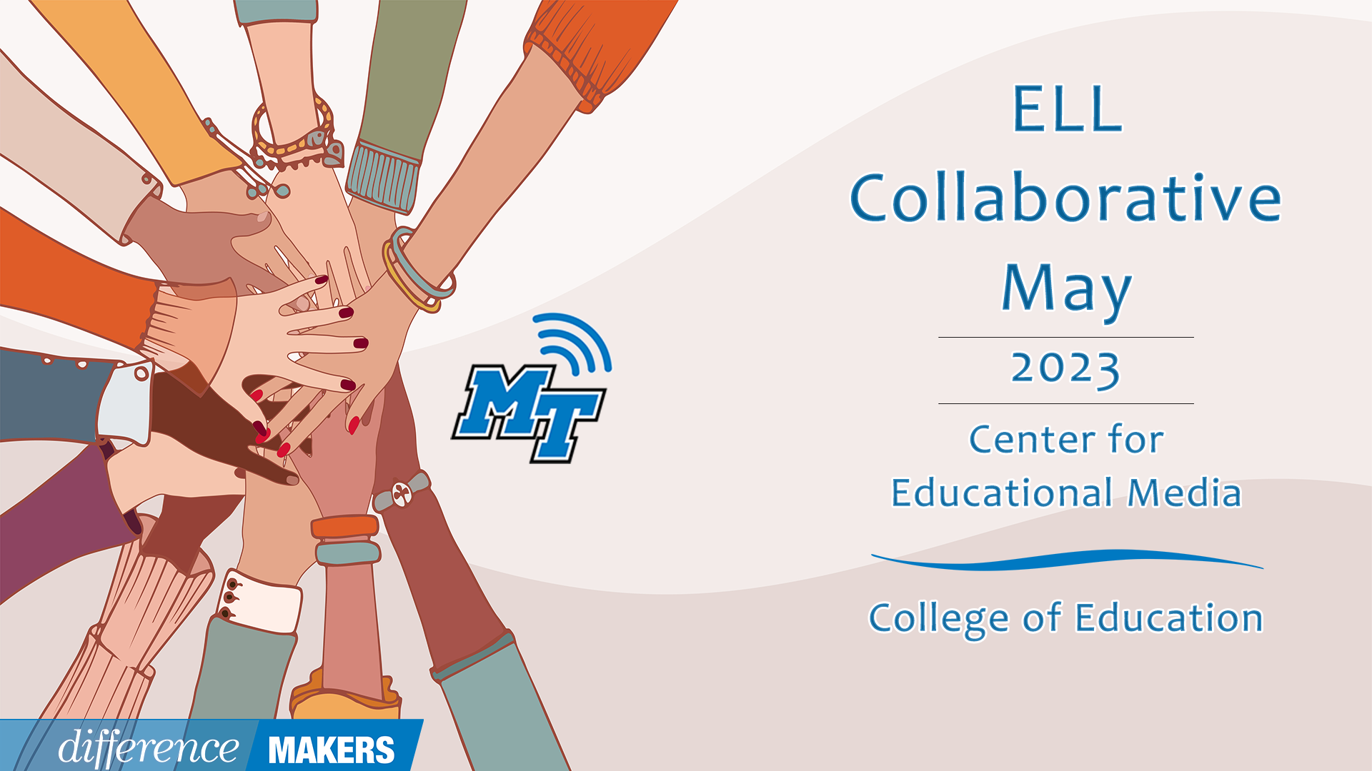
ELL Collaborative
Onsite/Virtual Conference
May 19, 2023

9:00- 9:15am Welcome/Introductions
- Dr. Laura Clark, Director, Center for Educational Media, MTSU
- Dr. Rick Vanosdall, Interim Dean, College of Education, MTSU
9:15-11:15 (Session 1) The Role of Language in Literacy Development
- Dr. Janna Brown McClain, Asst. Professor, Elementary and Special Education, MTSU
- Dr. Sungyoon Lee, Asst Professor, Elementary & Special Education, MTSU
- Aerial Mosley, Ed.S, Murfreesboro City Schools, English Language Development Specialist
- Q&A Facilitated by Dr. Laura Clark
11:15-11:25- Break
11:25-12:40(Session 2) WIDA Standards Framework: Instructional Strategies to Meet Academic
Language Expectations
- Shelly Misenheimer, ESL Instructor, Collierville Schools
- Katherine Perry, ESL Instructor, Arlington Community Schools
- Q&A Facilitated by Dr. Laura Clark
12:40-12:50 Break
12:50-1:20 TDOE Updates
- Joann Runion, Senior Director of Unique Learning Needs, TDOE
- Dr. Hannah Gribble, Title III and Migrant Education Program Grant Manager, TDOE
- Sara Kathryn Hendrix, TDOE Statewide EL Coordinator
- Q&A Facilitated by Dr. Laura Clark
1:20-1:40 Close/Announcements/Certificates
- Dr. Laura Clark, Director, Center for Educational Media, MTSU
- Chloe Walters, Ed. D, Program Specialist, Multilingual Learning, Diverse Learners Cooperative

