Dive into the WIDA Standards
Source: WIDA English Language Development Standards Framework, 2020 Digital Explorer
Standards Satchel
Website: https://satchel.commongoodlt.com/97c883b4-8590-454f-b222-f28298ec9a81/97c883b4-8590-454f-b222-f28298ec9a81
*You are not required to sign in to access the WIDA Framework.*

1. What are 3 ways that you can dive into the WIDA Standards?

1.
2.
3.

2. Click on the > Language Expectations by WIDA Standard Statements & Grade Level Cluster
How are the standards broken down?

ELD Standard 1: Language for
ELD Standard 2: Language for
ELD Standard 3: Language for
ELD Standard 4: Language for
ELD Standard 5: Language for

3. Select a Standard (1-5) that you would like to focus on.
What key information does each standard provide to begin planning your lesson?

______________________________________________________________________________

4. Input the details for your selected standard to complete the chart below.

Grades:
Specific Standard: | Example: ELD_SI-3.Narrate
Brief Description:
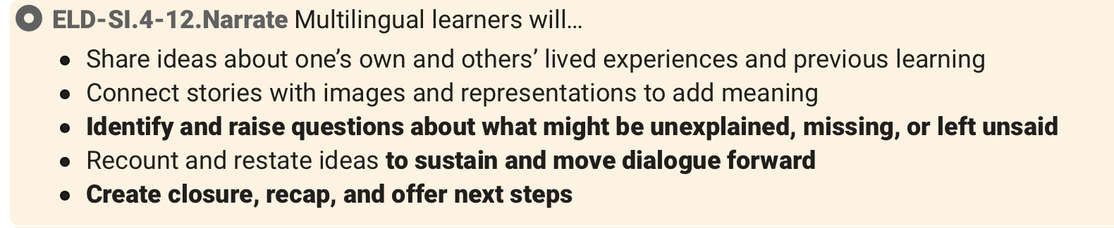

4. You can expand your selected standard, pin it, show it in metadata format (</>), print, download, or create a QR code for it.

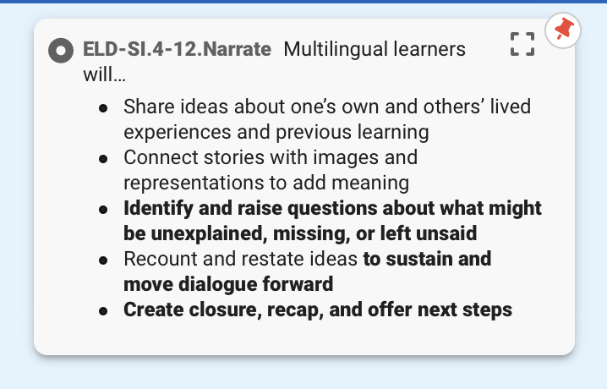

5. Pin your standard by clicking on the green push pin. Once pinned, you can view it on the
right side of your screen with a red push pen. This allows you to pin multiple standards at a time.

