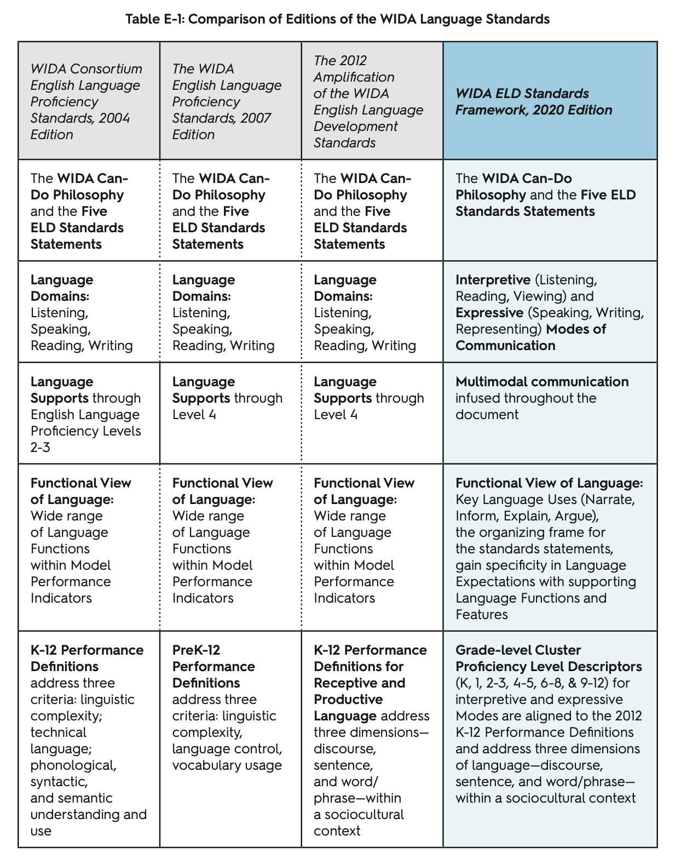

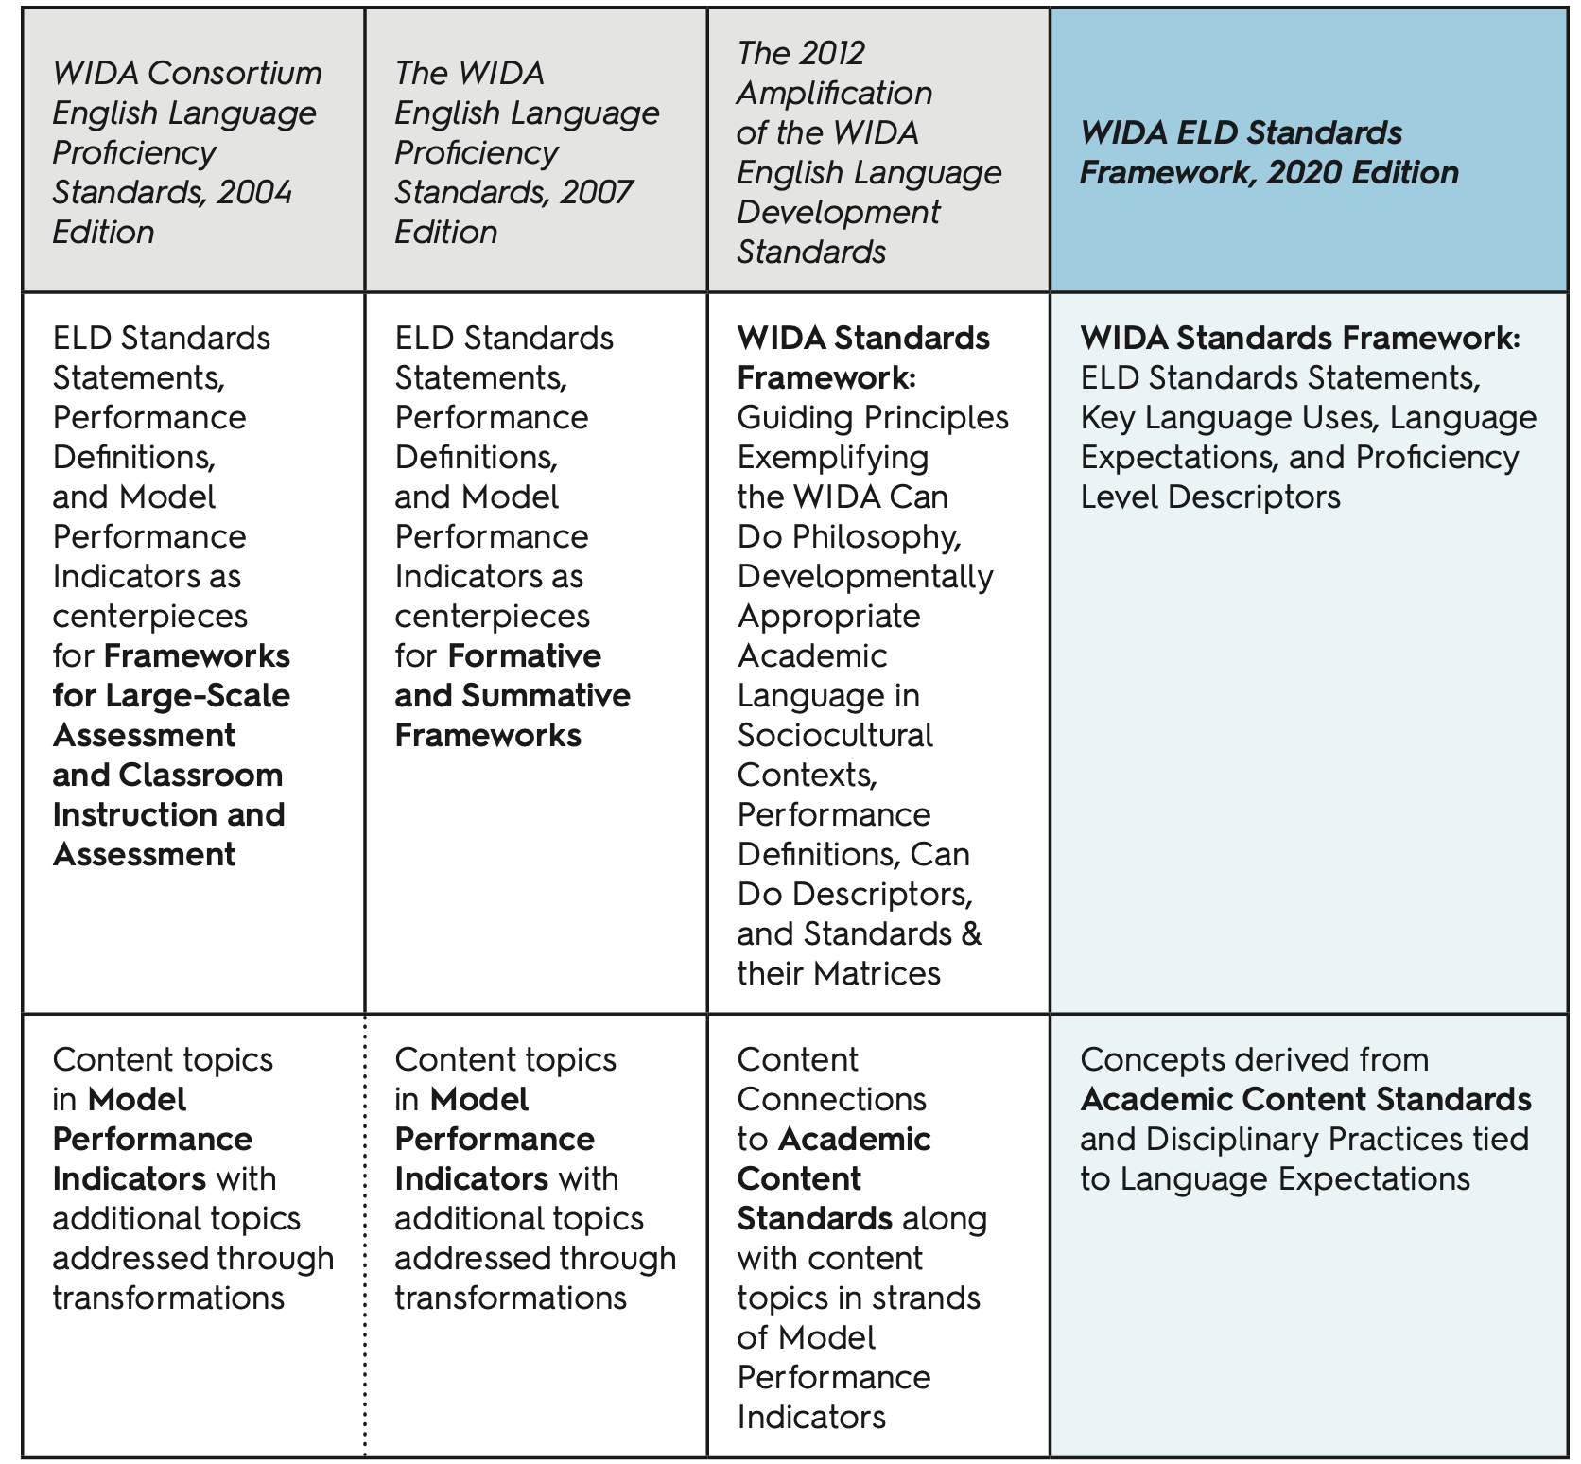

Source: : https://wida.wisc.edu/sites/default/files/Website/Teach/ELDstandards/AppendixE-Standards-Edition-Comparision.pdf

